WEEK 3 TASK

Advanced Data Analysis
and Visualization in Logistics
Exploratory analysis of a hypothetical logistics dataset using Python
Submission detail | Information
Course / Module | Logistics Data Analytics
Assignment | Week 3 – Advanced Data Analysis and Visualization
Prepared by | Student Name: Megha Chandra
Date | 08 September 2026

Purpose: This report defines a simulated shipment dataset, performs exploratory data analysis, presents six visualizations, interprets operational patterns, and recommends actions to improve delivery performance and transport-cost management.

1. Introduction and objectives
Logistics operations generate data about shipment volumes, transport modes, distances, delivery times, costs, and service reliability. Exploratory data analysis (EDA) converts these records into evidence for operational decisions. This task uses a reproducible hypothetical dataset to demonstrate summary statistics, distributions, relationships, and visual interpretation.
- Describe a simulated logistics dataset and its variables.
- Calculate central tendency, spread, and correlations.
- Visualize delivery-time patterns, mode differences, regional performance, shipment trends, and cost drivers.
- Translate findings into practical logistics recommendations.

2. Dataset simulation and structure
A synthetic dataset of 600 shipment records was generated using NumPy and pandas with random seed 42. It represents one calendar year (2025) and five operating regions. Each row represents one shipment. All values are simulated for educational purposes and do not describe a real company.
Variable | Type | Description
shipment_id | Text | Unique shipment identifier
ship_date | Date | Date shipment entered the network
region | Category | North, South, East, West, Central
transport_mode | Category | Road, Rail, Air, Sea
shipment_volume_units | Numeric | Units in shipment
distance_km | Numeric | Transport distance
delivery_days | Numeric | Elapsed delivery duration
transport_cost_usd | Numeric | Simulated transport cost in USD
on_time_delivery | Boolean | Whether shipment met simulated service target

Data-quality simulation: 12 records contain a missing value (six costs and six shipment volumes). For this descriptive exercise, the missing numeric values are filled with their column median. In real operations, missingness should first be investigated.

3. Data preparation and EDA
The analysis checks dimensions, data types, missing values, duplicate identifiers, and descriptive statistics. Dates are converted to datetime and grouped by month. A cost-per-unit feature is derived. Median imputation is used for the two incomplete numeric fields because it is less sensitive to skew than the mean.
# Load and inspect a CSV dataset
import pandas as pd
import matplotlib.pyplot as plt

df = pd.read_csv("Week_3_Hypothetical_Logistics_Dataset.csv")
print(df.shape)
print(df.info())
print(df.isna().sum())
print(df.describe(include="all"))

# Handle the simulated missing values
df["transport_cost_usd"] = df["transport_cost_usd"].fillna(
df["transport_cost_usd"].median())
df["shipment_volume_units"] = df["shipment_volume_units"].fillna(
df["shipment_volume_units"].median())

df["ship_date"] = pd.to_datetime(df["ship_date"])
df["month"] = df["ship_date"].dt.to_period("M").astype(str)
df["cost_per_unit"] = df["transport_cost_usd"] / df["shipment_volume_units"]

4. Descriptive statistics
Metric | Mean | Median | Standard deviation
Delivery time (days) | 5.95 | 5.80 | 2.47
Transport cost (USD) | 201.99 | 189.10 | 81.97
Shipment volume (units) | 256.7 | 243.0 | 138.2
Distance (km) | 1031.7 | 1016.0 | 570.5

Overall on-time delivery rate is 76.7%. Average delivery duration is 5.95 days and median duration is 5.80 days. The mean and median together describe the typical delivery time and help identify whether a smaller number of long deliveries affect the average. Average transport cost is $201.99 per shipment.

5. Visual analysis and interpretation

5.1 Delivery-time distribution – histogram
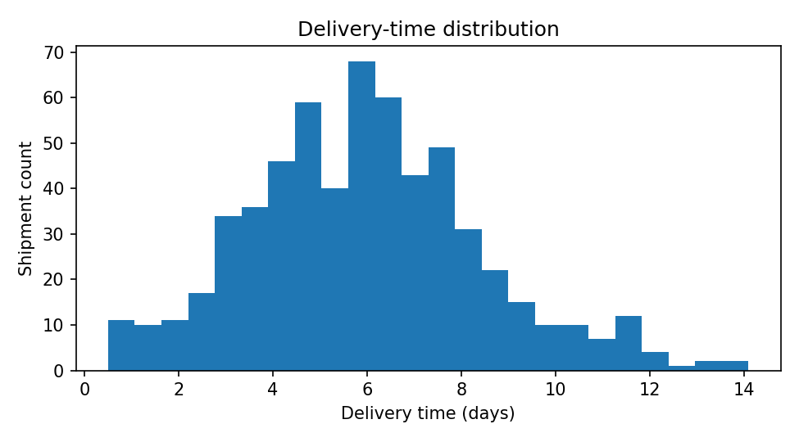
Figure 1. Distribution of delivery durations.
A histogram is suitable for a continuous variable. It shows where delivery durations cluster and whether the distribution has a long tail. The tail represents slower shipments that may need exception analysis. Managers should investigate unusually long deliveries rather than relying only on the average.

5.2 Delivery time by transport mode – box plot
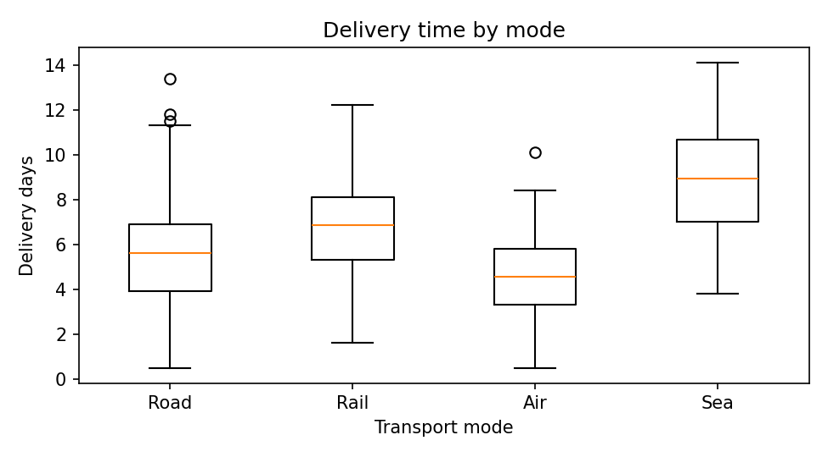
Figure 2. Delivery-time distributions across transport modes.
A box plot compares medians, spread, and potential extreme values across categories. In this simulation, Air generally has the shortest delivery time and Sea the longest; Road and Rail fall between them. Mode selection does not explain all variation: distance, geography, and congestion also affect performance.

5.3 Transport cost versus distance – scatter plot
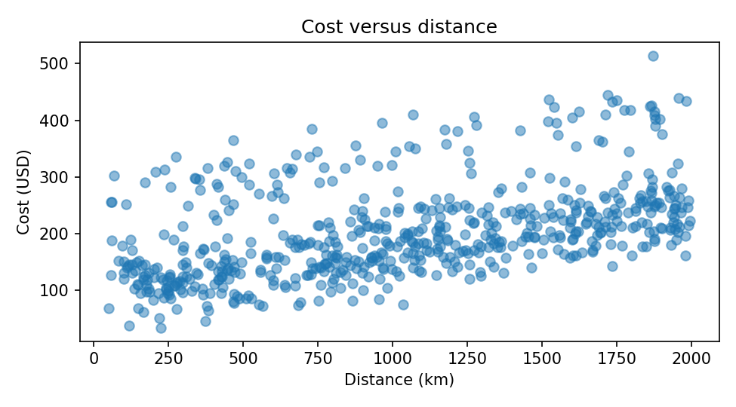
Figure 3. Relationship between transport distance and cost.
A scatter plot is appropriate for two numeric variables. Distance and transport cost have a Pearson correlation of 0.49, indicating a positive association in this generated dataset. Longer journeys generally cost more, while mode and shipment volume contribute to variation. Correlation does not establish causation.

5.4 Regional delivery performance – bar chart
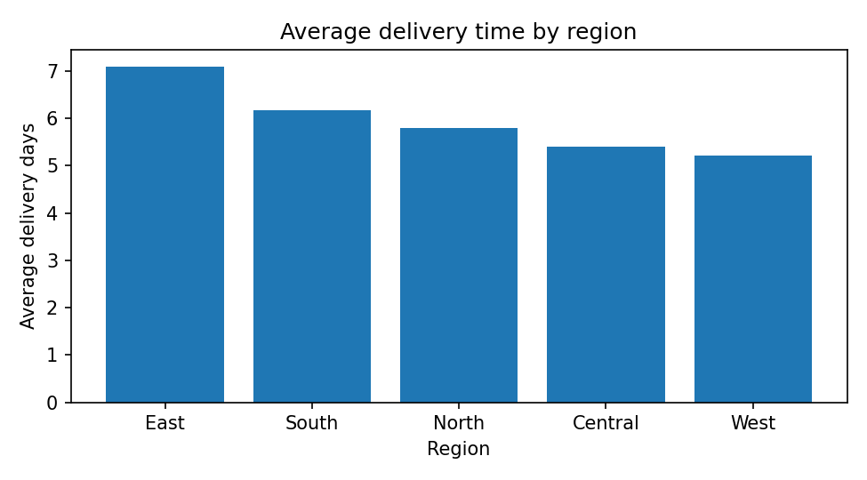
Figure 4. Average delivery duration by region.
The bar chart makes regional averages easy to compare. East has the highest average delivery time (7.09 days) and West the lowest (5.22 days). The slower region should be investigated for route design, hub dwell time, local congestion, and carrier performance.

5.5 Monthly shipment volume – line chart
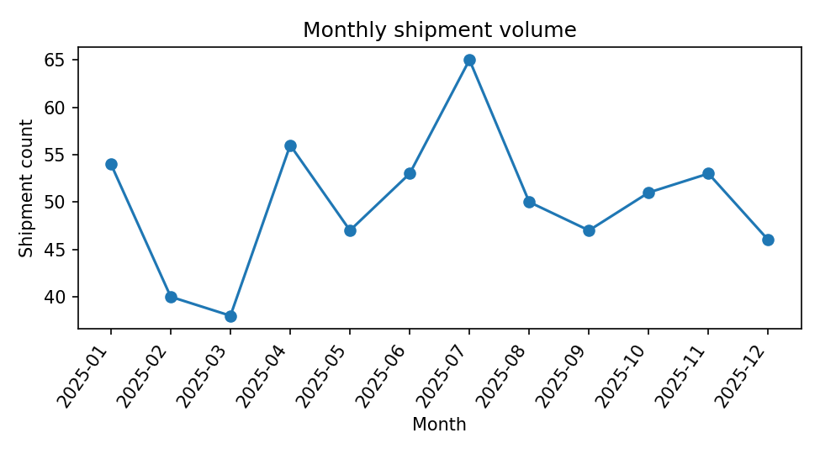
Figure 5. Monthly shipment counts.
A line chart is suitable for time-ordered data and makes peaks and dips visible. Monthly shipment counts fluctuate over the year. Capacity planners can use these patterns to anticipate labour, fleet, warehouse, and carrier requirements. Multiple years of observations would be needed to confirm recurring seasonality.

5.6 Correlation matrix – heatmap
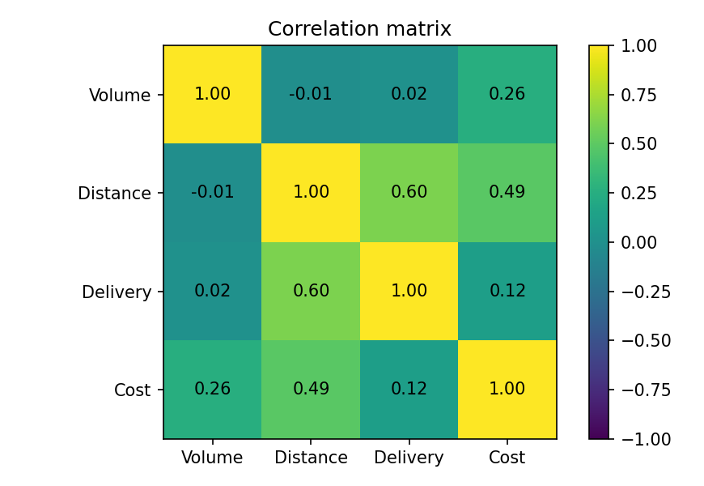
Figure 6. Pairwise correlations among numeric logistics variables.
The heatmap summarizes linear relationships. Cost is positively associated with distance (r=0.49) and volume (r=0.26). Distance and delivery time have a correlation of 0.60. Correlation is a screening tool; it may hide nonlinear patterns and does not prove cause and effect.

6. Grouped performance analysis
Mode | Shipments | Avg days | Avg cost USD | On-time %
Road | 322 | 5.47 | $172.83 | 78.6%
Rail | 126 | 6.84 | $195.79 | 76.2%
Air | 94 | 4.56 | $339.97 | 73.4%
Sea | 58 | 8.90 | $153.77 | 72.4%

The grouped summary supports mode-level comparison. The cheapest option is not necessarily the fastest, and the fastest option may cost more. Decisions should consider cost, delivery time, and service reliability together.

7. Python code for visualization
# Delivery-time distribution
plt.hist(df["delivery_days"], bins=24)
plt.xlabel("Delivery time (days)")
plt.ylabel("Shipment count")
plt.title("Distribution of delivery times")
plt.show()

# Compare delivery duration by transport mode
order = ["Road", "Rail", "Air", "Sea"]
groups = [df.loc[df.transport_mode == m, "delivery_days"] for m in order]
plt.boxplot(groups, tick_labels=order)
plt.xlabel("Transport mode")
plt.ylabel("Delivery days")
plt.show()

# Distance and cost relationship
plt.scatter(df["distance_km"], df["transport_cost_usd"], alpha=0.5)
plt.xlabel("Distance (km)")
plt.ylabel("Transport cost (USD)")
plt.show()

# Correlation matrix
numeric = df[["shipment_volume_units", "distance_km",
"delivery_days", "transport_cost_usd"]].corr()
plt.imshow(numeric, vmin=-1, vmax=1)
plt.colorbar()
plt.show()

8. Key findings and recommendations
- The simulated on-time delivery rate is 76.7%. Track this KPI with mean and median delivery duration to reveal both typical performance and severe delays.
- East has the slowest average delivery in this sample. Examine route and hub-level performance, congestion, and carrier service in this region.
- Compare transport modes using cost, speed, and on-time performance together. Reserve premium modes for time-sensitive freight where the service benefit justifies the cost.
- Distance is positively associated with transport cost (r=0.49). Monitor cost per kilometre and cost per unit, not only total spend.
- Use monthly shipment volume to inform staffing, fleet, warehouse space, and carrier capacity planning.
- Maintain data-quality checks for missing values, duplicate shipment identifiers, inconsistent units, and implausible delivery durations.

9. Limitations
The dataset is hypothetical and generated from assumptions, not actual logistics operations. Results are illustrative and must not be used as real-world benchmarks. The simulation does not include route sequences, weather, fuel prices, carrier identities, warehouse processing time, or contractual service levels. Real analysis should validate definitions, investigate missingness, review extreme observations, and compare multiple periods.

10. Conclusion
This task demonstrates how EDA and visualization reveal logistics patterns. Descriptive statistics summarize typical operations, distribution plots expose variation, grouped charts compare transport modes and regions, monthly trends support capacity planning, and correlation analysis highlights potential cost and delivery drivers. Used together, these methods help logistics teams prioritize investigation and make evidence-based decisions. Reliable conclusions depend on representative data, sound definitions, and validation against actual business conditions.

11. References and tools
- Python documentation: https://docs.python.org/3/
- pandas documentation: https://pandas.pydata.org/docs/
- NumPy documentation: https://numpy.org/doc/
- Matplotlib documentation: https://matplotlib.org/stable/

